A

PROJECT REPORT

ON

**“VEHICLE WITH ADVANCED SAFETY SYSTEM”**

PROJECT WORK SUBMITTED IN PARTIAL FULFILMENT OF

REQUIREMENTS FOR AWARD OF DIPLOMA CERTIFICATE IN

**ELECTRONICS ENGINEERING**

UNDER GUIDANCE OF

**PROF. SUBHASH KASTURE**

**DR. HEMANT PARDESHI**



**SUBMITTED BY**

**NAME ENROLLMENT NO**

SHUBHAM M. GIRI FS15EC028

GANESH R. GAONKAR FS15EC031

AASAVAREE P. RANE FS10EC042

GANESH S. PANCHAL FD16EC008

**DEPARTMENT OF ELECTRONICS ENGINEEREING**

**GOVERNMENT POLYTECHNIC MUMBAI**

**49, KHERWADI, ALIYAWAR JUNG MARG, BANDRA (E), MUMBAI 400051**

**2017-2018**

**GOVERNMENT POLYTECHNIC, MUMBAI**

**(An Autonomous Institute)**

**49, KHERWADI, ALI YAWAR JUNG MARG, BANDRA (E), MUMBAI 400 051**



**CERTIFICATE**

This is to certify the following students have successfully & satisfactorily completed the project work “**VEHICLE WITH ADVANCED SAFETY SYSTEM**” presented their report in the partial fulfilment of the requirements for “**Diploma in Electronics Engineering**” in Polytechnic Mumbai.

**ACADEMIC YEAR 2017-2018**

**NAME ENROLLMENT NO**

SHUBHAM M. GIRI FS15EC028

GANESH R. GAONKAR FS15EC031

AASAVAREE P. RANE FS10EC042

GANESH S. PANCHAL FD16EC008

**Project Guide Project Guide**

**(PRO.S.R.KASTURE) (DR.HEMANT PARDESHI)**

**Head of Department Examiner Principal (PRO.S.R.KASTURE) (PRO.SWATI DESHPANDE)**

**ACKNOWLEDGEMENT**

**ACKNOWLEDGEMENT**

We take this opportunity to express our deepest regards for everyone who have made invaluable contribution without which the completion of this project would not have been possible.

We sincerely acknowledge with deep sense of gratitude towards our project guide

**““PROF. SUBHASH KASTURE, DR.HEMANT PARDESHI”** without whose constant guidance, relentless support and much needed encouragement the realization of more idea into the project would not have been possible. We would also like to thank the staff of our college from the bottom of heart for their invaluable guidance and support.

We wish to express our sincere thanks to our Head of Department **“MR. S. R. KASTURE”** for his valuable suggestions.

No words could be good enough to express our deep sense of gratitude to our respected Principal ― **PROF. SWATI DESHPANDE**” for his kind blessings, inspiration and providing us good opportunity.

Last but not the least we are indebted to our own college **“GOVERNMENT POLYTECHNIC MUMBAI** ―For giving us this platform to express and inhibit our talent.

**PREFACE**

WE TAKE AN OPPORTUNITY TO PRESENT THE PROJECT REPORT ON **VEHICLE WITH ADVANCED SAFETY SYSTEM** AND PUT BEFORE READERS SOME USEFULL INFORMATION REGARDING TO OUR PROJECT.

WE HAVE MADE SINCERE ATTEMPTS AND TAKEN EVERY CARE TO PRESENT THIS MATTER IN PRECISE AND COMPACT FORM,THE LANGUAGE BEING AS SIMPLE AS POSSIBLE.WE ARE SURE THAT THE INFORMATION CONTAINED IN THIS VOLUME WOULD CERTAINLY PROVE USEFUL FOR READERS.

**ABSTRACT**

**ABSTRACT**

Now days, In India people faced some problems about increase in the number of car accident, increase in the number of car thefts, drink and drive, etc. So to overcome on this problem we come with solution called **“vehicle with advanced safety system”.** If we add this type of security in every vehicle it is very useful for everyone. We added some sensors in our project like Fingerprint sensor, Alcohol sensor, Gas sensor, Fire sensor, Etc.

By using fingerprint sensor we protect the vehicle from thefts. By using fingerprint sensor we start the vehicle. If any person who drink alcohol & travel from the vehicle we find that person by using alcohol sensor. With the help of gas leakage detector we detect the hazardous gas who present in our car which are very harmful for our vehicle.

Suppose unfortunately, there will be a vehicle accident is done in future, then with the help of GSM Module the message of vehicle accident is automatically send to that number which is saved by the microcontroller. Also we get exact location of vehicle by using GPS. On highway or on road there are some speed limits i.e. 80KM, 100KM, Etc. In this project we make a road and set some speed limits, like 80KM, 100KM, 120KM, Etc. If driver over speed the vehicle and break the speed limit then message of over speeding is sent to traffic police by using GSM Module. Then traffic police get exact location of car by using GPS. So, this concept will very useful in future.

**INDEX**

**INDEX**

|  |  |  |
| --- | --- | --- |
| **CHAPTER** | **NAME OF THE CHAPTER** | **PAGE NO.** |
| **CHAPTER 1** | **INTRODUCTION** | **10-11** |
| **CHAPTER 2** | **COMPONENT LIST** | **12-13** |
| **CHAPTER 3** | **ACTION PLAN** | **14-16** |
| **CHAPTER 4** | **BLOCK DIAGRAM** | **17-21** |
| **CHAPTER 5** | **CIRCUIT DIAGRAM** | **22-28** |
| **CHAPTER 6** | **REQUIREMENT OF HARDWARE** | **29-40** |
| **CHAPTER 7** | **FABRICATION OF PCB** | **41-44** |
| **CHAPTER 8** | **PCB LAYOUT** | **45-49** |
| **CHAPTER 9** | **SOFTWARE DEVELOPMENT** | **50-57** |
| **CHAPTER 10** | **ADVANTAGES AND APPLICATIONS** | **58-59** |
| **CHAPTER 11** | **FUTURE SCOPE AND BENIFITS** | **60-61** |
| **CHAPTER 12** | **CONCLUSION** | **62-63** |
| **CHAPTER 13** | **SNAPSHOT** | **64-65** |
| **CHAPTER 14** | **BIBILOGRAPHY** | **66-67** |
| **CHAPTER 15** | **DATASHEETS** | **68-75** |

1. **INTRODUCTION**

**INTRODUCTION**

Today’s world is developing at very high speed. Everyday new technology is discovered however at the same time everyone is facing many problems in smart cities. Some of these problems are related to Security of our vehicles, like increase in the number of car accident, increase in the number of car thefts, drink and drive, etc. So to overcome on this problem we come with solution called “vehicle with advanced safety system”.

If we add this type of security in every vehicle it is very useful for everyone. We added some sensors in our project like Fingerprint sensor, Alcohol sensor, Gas sensor, Fire sensor, etc. As a student of Electronics Engineering, This project interested and expose us to field of Mechanical, Design engineering, Electronics devices, Programming languages. On the whole, in this project write program to e sensor, Etc. So this is a concept of our project i.e. Vehicle with advanced safety system.

**2. LIST OF COMPONENTS**

**LIST OF COMPONENTS**

|  |  |  |  |
| --- | --- | --- | --- |
| **SR NO.** | **DESCRIPTION** | **QUANTITY** | **PRICE** |
| **1.** | **DC SOCKET** | **1** | **5** |
| **2.** | **LED** | **5** | **5** |
| **3.** | **RESISTOR** | **10** | **10** |
| **4.** | **PCB** | **2** | **70** |
| **5.** | **CAPACITOR** | **6** | **6** |
| **6.** | **IC BASE** | **2** | **8** |
| **7.** | **GPS** | **1** | **980** |
| **8.** | **GSM** | **1** | **900** |
| **9.** | **AT89S52** | **1** | **60** |
| **10.** | **ATMEGA328** | **1** | **120** |
| **11.** | **LCD 20X4** | **1** | **380** |
| **12.** | **7805 IC** | **2** | **14** |
| **13.** | **PUSH SWITCH** | **4** | **8** |
| **14.** | **RF434** | **1** | **160** |
| **15.** | **DC MOTOR (12V)** | **4** | **600** |
| **16.** | **VOICE MODULE** | **1** | **750** |
| **17.** | **FIRE SENSOR** | **1** | **95** |
| **18.** | **GAS SENSOR** | **1** | **250** |
| **19.** | **FINGERPRINT SENSOR** | **1** | **2150** |
| **20.** | **BUZZER** | **1** | **10** |
| **21.** | **ADAPTOR (12V 2A)** | **1** | **150** |
| **22.** | **WIRES** | **-** | **30** |

**ACTIVITY PLAN**

|  |  |  |  |  |  |
| --- | --- | --- | --- | --- | --- |
| **No** | **Target** | **Activity** | **Responsibility** | **Dates** | **Remark** |
| **1** | **Group**  **formation** | **The group of 4 student is formed:**  **1. Shubham Giri**  **2. GaneshGaonkar**  **3. Aasavaree Rane**  **4. Ganesh Panchal** |  | **14 July-21 July** | **Target Completed** |
| **2** | **Searching**  **various**  **projects** | **1.Searching project on websites through Internet**  **2.Search from the magazines, collage faculty** | **All members** | **21 July-28 July** | **Target Completed** |
| **3** | **Listing the project** | **List of project is,**  **1. Vehicle with advanced safety system**  **2. Fire Fighting Robot**  **3. Solar Tracking System** | **All members** | **28 July-**  **4 Aug** | **Target Completed** |
| **4** | **Searching**  **concrete**  **information** | **1.Block Diagram & circuit Diagram**  **2. Information and personal opinion & priority according to parameter & Information collected in form of soft copy.** | **All members** | **28 July-**  **4 Aug** | **Target Completed** |
| **5.** | **Priority to the project** | **Preferences to the project.** | **All members** | **28 July-**  **4 Aug** | **Target Completed** |
| **6.** | **Finalizing project** | **1. The project presentation is shown to college faculty & Accepting their advice.**  **2. The final project is Vehicle with advanced safety system** | **All members** | **4**  **Aug- 11**  **Aug** | **Target Completed** |

|  |  |  |  |  |  |
| --- | --- | --- | --- | --- | --- |
| **7** | **vehicle model** | **1. We make a vehicle model for our project** | **All members** | **18 Aug-**  **18 Sept** | **Target completed** |
| **8** | **Making PCB,**  **layout &**  **purchasing**  **components** | **1. Purchasing the components from the market.**  **2. Making PCB layout with the help of EXPRESS PCB software.** | **All members** | **19**  **Sep-**  **6 Oct** | **Target completed** |
| **9** | **Assembling component** | **1. Components are mounted on PCB.**  **2. Connectivity of the tracks on PCB is tested by the multimeter.**  **3. Uncontinuous tracks on PCB are rearranged & joined by jumper.** |  | **7 Oct-**  **22 Oct** |  |
| **10** | **Making small PowerPoint presentation** | **For preparation of seminar we required points which will be necessary for making PPT.** | **All members** | **23 Oct-**  **5 Nov** | **Target completed** |
| **11** | **Completing hardware** | **Connecting all hardware part to each other.** | **All members** | **6 Nov-**  **13 Nov** | **Target completed** |
| **12** | **Decorating the constructed model** | **Preparation for projects exhibitions.** | **All members** | **1 Jan-**  **30 Jan** | **Target completed** |
| **13** | **Preparation of Project Report** | **Make black book of our project** | **All members** | **1 Feb-**  **17 April** | **Target completed** |

1. **BLOCK DIAGRAM**

* **BLOCK DIAGRAM OF OUR SYSTEM:-**

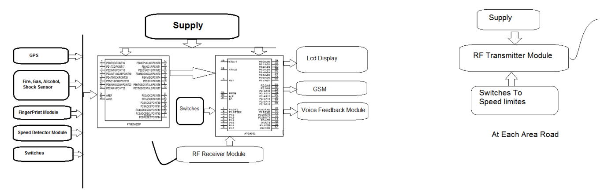

* **MICROCONTROLLER-:**

A microcontroller is a functional computer system on a chip. It is a designed to perform a specific task and it contain processor core, memory and programmable input or output peripherals. In the system it is used for all the electronics setup. Interfacing and holding all electronics components.

Here we are using AT89S52 controller. This is used to control all the operations of a circuit to get the accurate result. The micro controller we use is of the 40 pins and of 4 ports. Each port consists of the 8 pins. Generally the controller works on the transistor logic.

* **GPS MODULE-:**

A Global Positioning System also known as GPS. This system designed to help navigate on the earth, in the air, provides and on water. It tracks your time basis. The device provides autonomous Geospatial positioning with global coverage. GPS Accuracy depends on a number of variables, most notably signal to noise ratio (noisy reception), satellite position, weather and obstructions such as buildings and mountains. These factors can create errors in your perceived location. Signal noise usually creates an error from around one to ten meters. Mountains, buildings and other things that might obstruct the path between the receiver and the satellite can cause three times as much error as signal noise. A GPS receiver must be able to get a lock on 4 satellites to be able to solve for a position. The first lock it gets allows the receiver to obtain the  information and thus what other satellites it should listen for. Although it is possible to get a position from less than 4 satellites, the margin of error of this position can be rather large.

* **GSM MODULE:-**

A GSM module digitizes and reduces the data, then send it down through channel with two different stream of client data each in its own particular time slots. This block is interfaced to microcontroller through the level shifter IC max 232. The SIM card is mounted on GSM module. Upon receiving signal from microcontroller through weight sensor the controller send a code comprising of address code and send to service provider displaying message on the LCD.

* **FINGERPRINT SENSOR-:**

It is an electronics device used to capture digital image of fingerprint pattern. The captured image is called a live scan. This live scan is digitally processed to create a biometrical template which is stored and matching.

* **GAS SENSOR-:**

It senses the toxic gases like Carbon monoxide, chlorine, nitrogen oxides. They function via electrodes signal when gas is detected.

* **ALCOHOL SENSOR-:**

This sensor is suitable for detecting alcohol concentration on your breath, just like your common breathalyzer. It has high sensitivity and fast response time. Sensor provides an analog resistive output based on alcohol concentration.

* **SHOCK SENSOR-:**

It helps to protect the body of your car plus it act as a warning to potential thief that alarm is fitted.

* **FIRE SENSOR-:**

It helps to detect the fire in the car. If any person smoking in a car then we get the message with the help of Fire detector and GSM.

* **SPEED DECTOR MODULE-:**

It helps to detect the speed of vehicle. If there is over speeding then it will detect by Speed dector module.

* **RF TRANSMITTER AND RECEIVER MODULE-:**

RF TRANSMITTER and RECEIVER MODULE is used to transmit and receive the data simultaneously. This is block diagram description of our system.

1. **CIRCUIT DIAGRAM**

* **CIRCUIT DIAGRAM (1)-:**

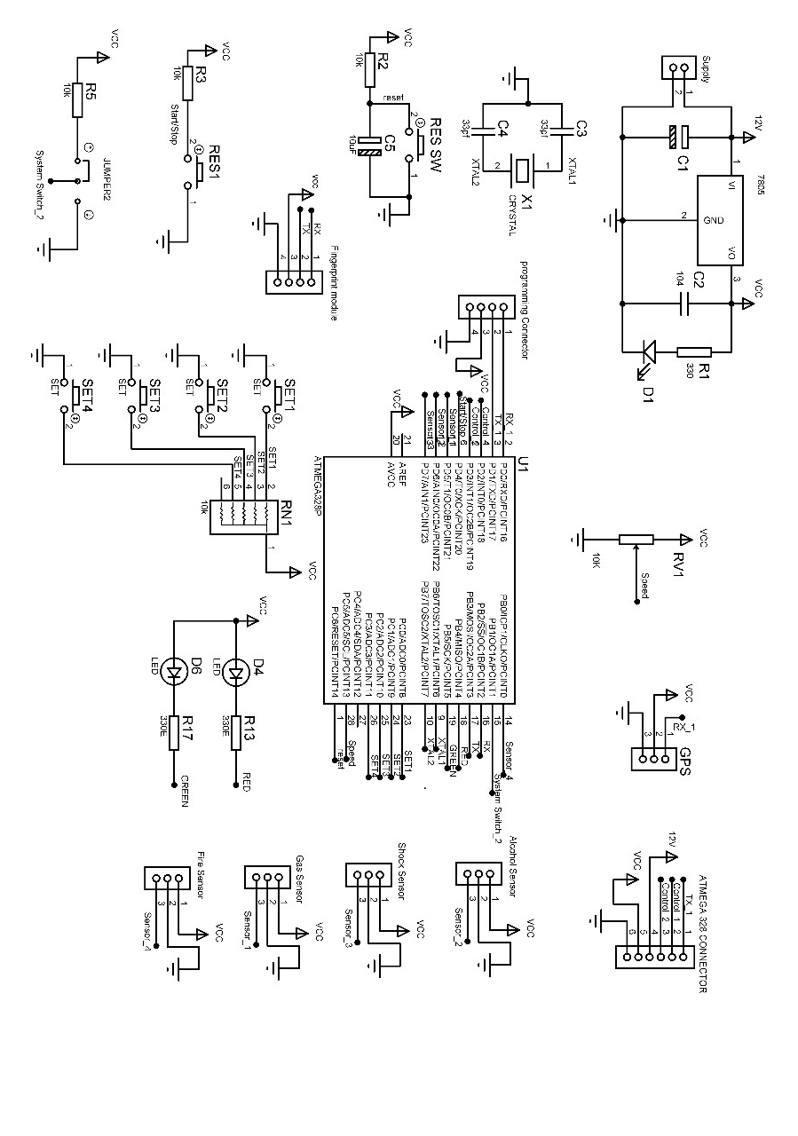

* **CIRCUIT DIAGRAM (1) EXPLAINATION-:**

Above circuit diagram shows the circuit diagram (Circuit No 1) of our project i.e. VEHICLE WITH ADVANCED SAFETY SYSTEM. The AT89S52 IC has 4 different ports, each one having 8 Input/output lines providing a total of 32 I/O lines. Those ports can be used to output DATA Encoder do other devices, or to read the state of a sensor, or a switch. Most of the ports of the 89S52 have 'dual function' meaning that they can be used for two different functions.

The first one is to perform input/output operations and the second one is used to implement special features of the microcontroller like counting external pulses, interrupting the execution of the program according to external events, performing serial data transfer or connecting the chip to a computer to update the software. Each port has 8 pins, and will be treated from the software point of view as an 8-bit variable called 'register', each bit being connected to a different Input Output pin. This is first circuit of our project.

* **CIRCUIT DIAGRAM 2-:**

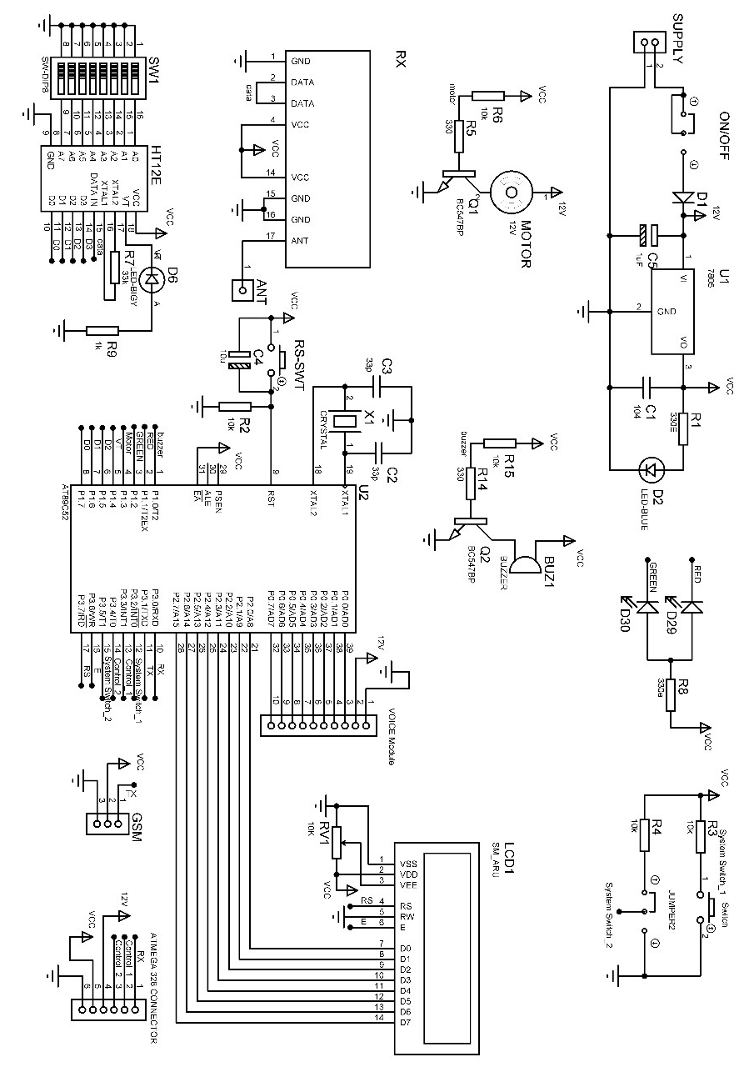

* **CIRCUIT DIAGRAM 2 EXPLAINATION-:**

This is circuit number 2 of our project. The AT89C52 is a low-power, high-performance CMOS 8-bit microcomputer with 8K bytes of Flash programmable and erasable read only memory (PEROM). The device is manufactured using Atmel’s high-density non volatile memory technology and is compatible with the industry-standard 80C51 and 80C52 instruction set and pin out.

The on-chip Flash allows the program memory to be reprogrammed in-system or by a conventional non volatile memory programmer. By combining a versatile 8-bit CPU with Flash on a monolithic chip, the Atmel AT89C52 is a powerful microcomputer which provides a highly-flexible and cost-effective solution to many embedded control applications.

AT89C52 provides the following standard features: 8K bytes of Flash, 256 bytes of RAM, 32 I/O lines, three 16-bit timer/counters, a six-vector two-level interrupt architecture, a full-duplex serial port, on-chip oscillator, and clock circuitry. In addition, the AT89C52 is designed with static logic for operation down to zero frequency and supports two software selectable power saving modes. The Idle Mode stops the CPU while allowing the RAM, timer/counters, serial port, and interrupt system to continue function. The Power-down mode saves the RAM contents but freezes the oscillator, disabling all other chip functions until the next hardware reset. This is second circuit of our project.

* **SPEED LIMIT MOULE ON ROAD-:**

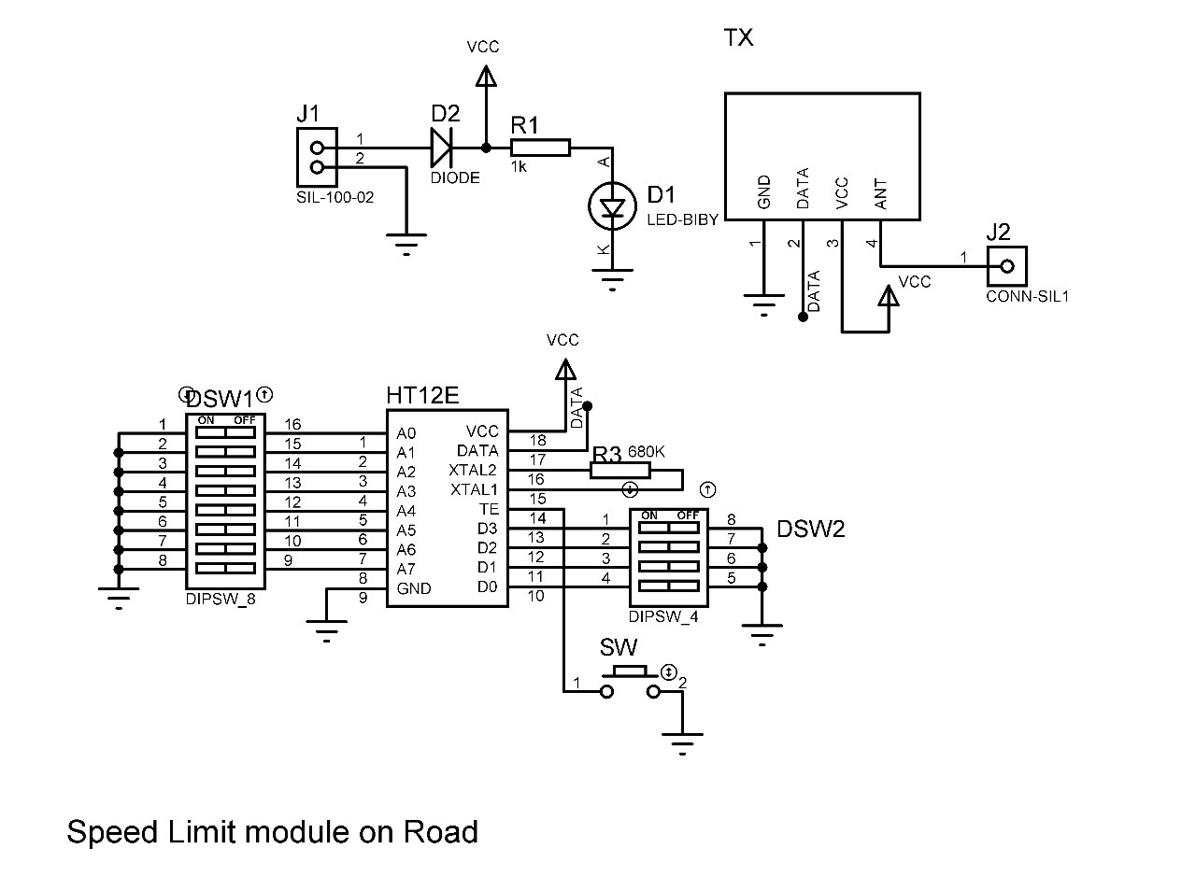

* **SPEED LIMIT MODULE EXPLAINATION-:**

The 212 encoders are a series of CMOS LSIs for remote control system applications. They are capable of encoding information which consists of N address bits and 12_N data bits. Each address/data input can be set to one of the two logic states. The programmed addresses/data are transmitted together with the header bits via an RF or an infrared transmission medium upon receipt of a trigger signal. The capability to select a TE trigger on the HT12E or a DATA trigger on the HT12A further enhances the application flexibility of the 212 series of encoders. The HT12A additionally provides a 38 kHz carrier for infrared systems.

The status of each address/data pin can be individually pre-set to logic _high_ or _low_. If a transmission-enable signal is applied, the encoder scans and transmits the status of the 12 bits of address/data serially in the order A0 to AD11 for the HT12E encoder and A0 to D11 for the HT12A encoder. During information transmission these bits are transmitted with a preceding synchronization bit. If the trigger signal is not applied, the chip enters the standby mode and consumes a reduced current of less than 1_A for a supply voltage of 5V. Usual applications preset the address pins with individual security codes using DIP switches or PCB wiring, while the data is selected by push buttons or electronic switches. This is speed limit module circuit of our project.

**4. REQUIREMET OF**

**HARDWARE**

1. **MICROCONTROLLER-:**

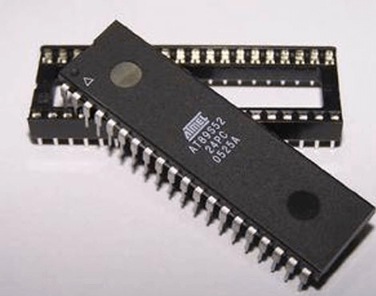

The AT89S52 is a low-power, high-performance CMOS 8-bit microcontroller with 8K bytes of in-system programmable Flash memory. The device is manufactured using Atmel‘s high-density non volatile memory technology and is compatible with the industry-standard 80C51 instruction set and pin out. The on-chip Flash allows the program memory to be reprogrammed in-system or by a conventional non volatile memory programmer. By combining a versatile 8-bit CPU with in-system programmable Flash on a monolithic chip, the Atmel AT89S52 is a powerful microcontroller which provides a highly-flexible and cost-effective solution to many embedded control applications.

The AT89S52 provides the following standard features: 8K bytes of Flash, 256 bytes of RAM, 32 I/O lines, Watchdog timer, two data pointers, three 16-bit timer/counters, a six-vector two-level interrupt architecture, a full duplex serial port, on-chip oscillator, and clock circuitry. In addition, the AT89S52 is designed with static logic for operation down to zero frequency and supports two software selectable power saving modes. The Idle Mode stops the CPU while allowing the RAM, timer/counters, serial port, and interrupt system to continue functioning.

1. **LCD DISPLAY-:**

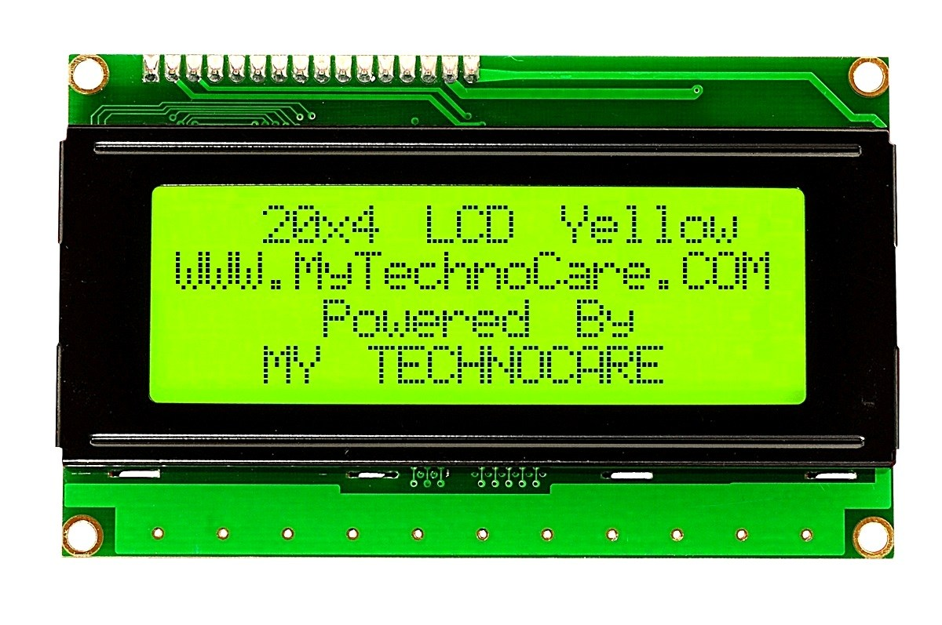

LCD (Liquid Crystal Display) screen is an electronic display module and find a wide range of applications. A 16x2 LCD display is very basic module and is very commonly used in various devices and circuits. These modules are preferred over seven segment sand other multi segment LEDs. The reasons being: LCDs are economical; easily programmable; have no limitation of displaying special & even custom characters (unlike in seven segments), animation send so on.

A **16x2 LCD** means it can display 16 characters per line and there are 2 such lines. In this LCD each character is displayed in 5x7 pixel matrix. This LCD has two registers, namely, Command and Data.

The command register stores the command instructions given to the LCD. A command is an instruction given to LCD to do a predefined task like initializing it, clearing its screen, setting the cursor position, controlling display etc. The data register stores the data to be displayed on the LCD. The data is the ASCII value of the character to be displayed on the LCD. Click to learn more about internal structure of a LCD.

1. **DC MOTOR-:**



In any electric motor, operation is based on simple electromagnetism. A current-carrying conductor generates a magnetic field; when this is then placed in an external magnetic field, it will experience a force proportional to the current in the conductor, and to the strength of the external magnetic field. The internal configuration of a DC motor is designed to harness the magnetic interaction between a current-carrying conductor and an external magnetic field to generate rotational motion.



In a simple 2-pole DC electric motor, as shown above (here red (right side) represents a magnet or winding with a "North" polarization, while green (left side) represents a magnet or winding with a "South" polarization).

Every DC motor has six basic parts axle, rotor (a.k.a., armature), stator, commutator, field magnet(s), and brushes. In most common DC motors (and all that Beamers will see), the external magnetic field is produced by high-strength permanent magnets.

The stator is the stationary part of the motor this includes the motor casing, as well as two or more permanent magnet pole pieces. The rotor (together with the axle and attached commutator) rotates with respect to the stator. The rotor consists of windings (generally on a core), the windings being electrically connected to the commutator. The above diagram shows a common motor layout with the rotor inside the stator (field) magnets.

The geometry of the brushes, commutator contacts, and rotor windings are such that when power is applied, the polarities of the energized winding and the stator magnet(s) are misaligned, and the rotor will rotate until it is almost aligned with the stator's field magnets. As the rotor reaches alignment, the brushes move to the next commutator contacts, and energize the next winding. Given our example two-pole motor, the rotation reverses the direction of current through the rotor winding, leading to a "flip" of the rotor's magnetic field, driving it to continue rotating.

1. **FINGREPRINT SENSOR-:**

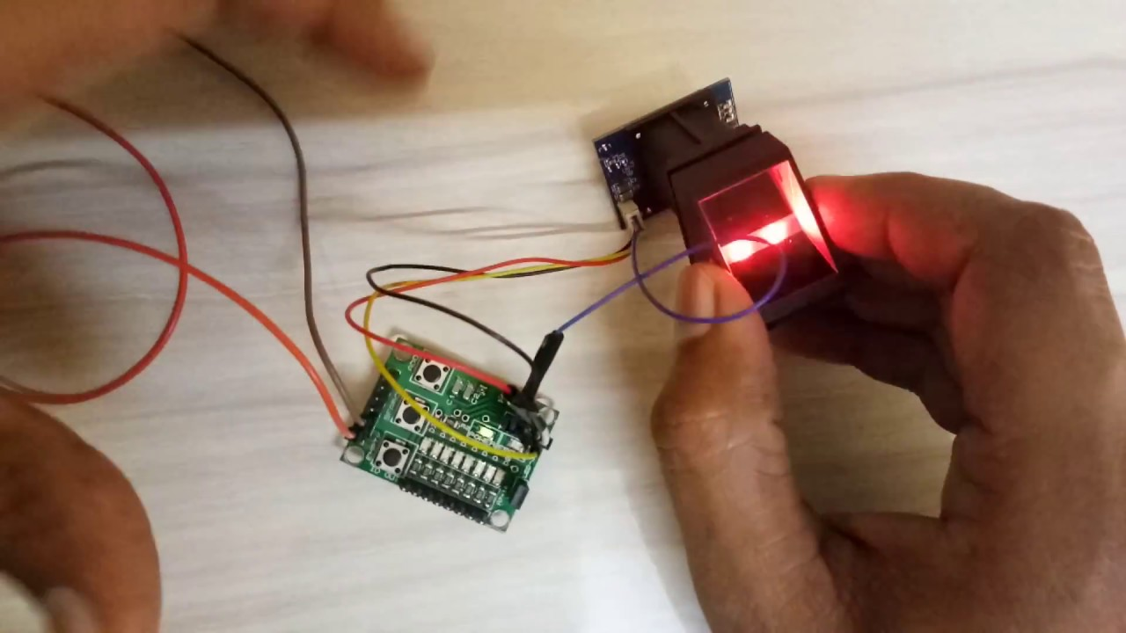

Secure your project with biometrics - this all-in-one optical fingerprint sensor will make adding fingerprint detection and verification super simple. These modules are typically used in safes - there's a high powered DSP chip that does the image rendering, calculation, feature-finding and searching. Connect to any microcontroller or system with TTL serial, and send packets of data to take photos, detect prints, hash and search. You can also enroll new fingers directly - up to 162 finger prints can be stored in the onboard FLASH memory. There's a red LED in the lens that lights up during a photo so you know its working. We like this particular sensor because not only is it easy to use, it also comes with fairly straight-forward Windows software that makes testing the module simple - you can even enroll using the software and see an image of the fingerprint on your computer screen. But, of course, we wouldn't leave you a datasheet and a "good luck!" - we wrote a full library so that you can get running in under 10 minutes. The library can enroll and search so its perfect for any project. We've also written a detailed tutorial on wiring and use. This is by far the best fingerprint sensor you can get.

* **FEATURES OF FINGREPRINT SENSOR-:**

1. Supply voltage: 3.6 - 6.0VDC

2. Operating current: 120mA max

3. Peak current: 150mA max

4. Fingerprint imaging time: <1.0 Seconds

5. Window area: 14mm x 18mm

6. Signature file: 256 bytes

7. Template file: 512 bytes

8. Storage capacity: 162 templates

9. Safety ratings (1-5 low to high safety)

1. **GAS SENSOR-:**

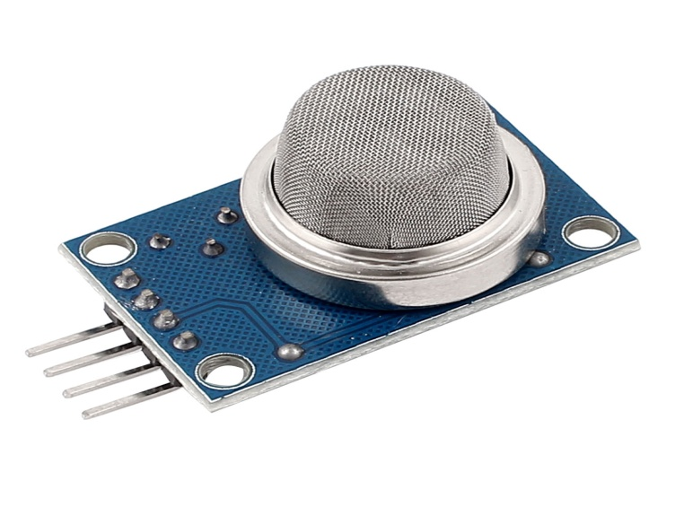

Using an MQ sensor it detects a gas is very easy. You can either use the digital pin or the analog pin to accomplish this. Simply power the module with 5V and you should notice the power LED on the module to glow and when no gas it detected the output LED will remain turned off meaning the digital output pin will be 0V. Remember that these sensors have to be kept on for pre-heating time (mentioned in features above) before you can actually work with it. Now, introduce the sensor to the gas you want to detect and you should see the output LED to go high along with the digital pin, if not use the potentiometer until the output gets high. Now every time your sensor gets introduced to this gas at this particular concentration the digital pin will go high (5V) else will remain low (0V).

You can also use the analog pin to achieve the same thing. Read the analog values (0-5V) using a microcontroller, this value will be directly proportional to the concentration of the gas to which the sensor detects. You can experiment with this values and check how the sensor reacts to different concentration of gas and develop your program accordingly.

* **FEATURES OF GAS SENSOR**-:
* Operating Voltage is +5V
* Can be used to Measure or detect LPG, Alcohol, Propane, Hydrogen, CO and even methane
* Analog output voltage: 0V to 5V
* Digital Output Voltage: 0V or 5V (TTL Logic)
* Preheat duration 20 seconds
* Can be used as a Digital or analog sensor
* The Sensitivity of Digital pin can be varied using the potentiometer

1. **ALCOHOL SENSOR-:**

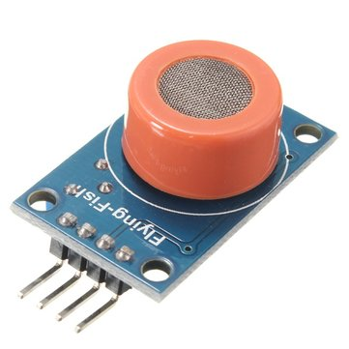

This module is made using Alcohol Gas Sensor MQ3. It is a low cost semiconductor sensor which can detect the presence of alcohol gases at concentrations from 0.05 mg/L to 10 mg/L. The sensitive material used for this sensor is SnO2, whose conductivity is lower in clean air. It’s conductivity increases as the concentration of alcohol gases increases. It has high sensitivity to alcohol and has a good resistance to disturbances due to smoke, vapour and gasoline. This module provides both digital and analog outputs. MQ3 alcohol sensor module can be easily interfaced with Microcontrollers, etc.

This alcohol sensor is suitable for detecting alcohol concentration on your breath, just like your common breathalyzer. It has a high sensitivity and fast response time. Sensor provides an analog resistive output based on alcohol concentration. The drive circuit is very simple, all it needs is one resistor. A simple interface could be a 0-3.3V ADC.

* **FEATURES OF ALCOHOL SENSOR-:**
* 5V operation
* Simple to use
* LEDs for output and power
* Output sensitivity adjustable
* Analog output 0V to 5V
* Digital output 0V or 5V
* Low Cost
* Fast Response
* Stable and Long Life
* Good Sensitivity to Alcohol Gas
* Both Digital and Analog Outputs
* On-board LED Indicator

1. **SHOCK SENSOR-:**

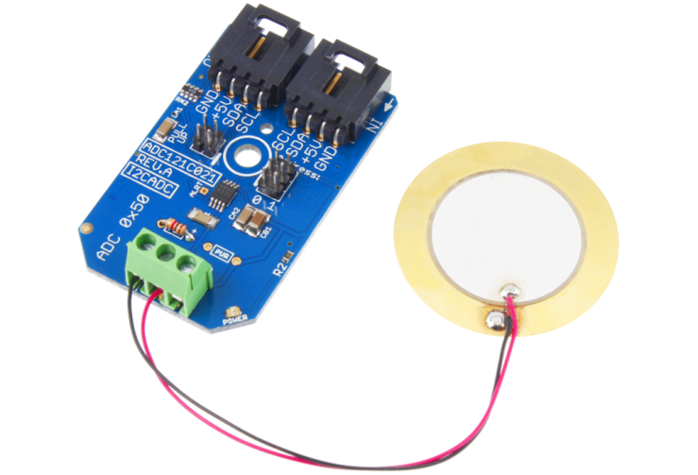

These days, only the cheapest car alarm packages rely on door sensors alone. Advanced alarm systems mostly depend on shocksensors to deter thieves and vandals.

The idea of a shock sensor is fairly simple: If somebody hits, jostles or otherwise moves your car, the sensor sends a signal to the brain indicating the intensity of the motion. Depending on the severity of the shock, the brain signals a warning horn beep or sounds the full-scalealarm.

* **FEATURES OF SHOCK SENSOR-:**
* Able to evaluate easily the sensor by supplying power to the evaluation module.
* It is possible to detect acceleration in frequency band up to 1KHz.
* PKGS-25SXA P1-R Shock Sensor (1 axis of detection) has been installed.
* Due to the compactness (16.8mm x 10.8mm x 3.55mm), it is easy to install the module in your
* Evolution environment.
* The portions of sensor and circuits are shielded by countermeasure against external noise.
* With supplied connector, the connection between module and your equipment is easy.

1. **FIRE SENSOR-:**

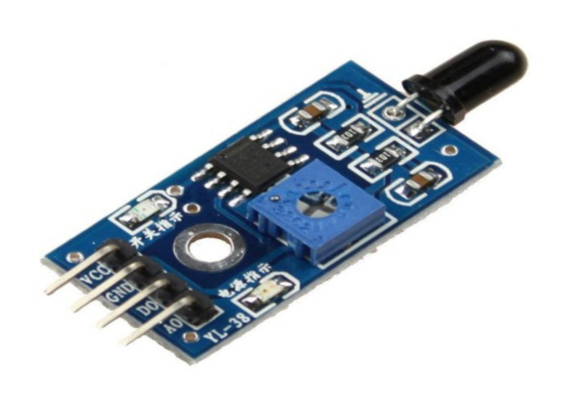

Fire sensor is the most sensitive to ordinary light that is why its reaction is generally used as flame alarm purposes. This module can detect flame or wavelength in 760 nm to 1100 nm range of light source. Small plate output interface can and single-chip can be directly connected to the microcomputer IO port. The sensor and flame should keep a certain distance to avoid high temperature damage to the sensor. The shortest test distance is 80 cm, if the flame is bigger, test it with farther distance. The detection angle is 60 degrees so the flame spectrum is especially sensitive. The detection angle is 60 degrees so the flame spectrum is especially sensitive.

* **FEATURES OF FIRE SENSOR-:**
* On-board LM393 voltage comparator chip and infrared sensing probe.
* Support 5V/3.3V voltage input.
* On-board signal output indication, output effective signal is high level, and the same time the indicator light up, output signal can directly connect with microcontroller IO.
* Signal detection sensitivity can be adjusted.
* Reserved a line voltage compare circuit (P3 is leaded out).

1. **GSM MODULE-:**

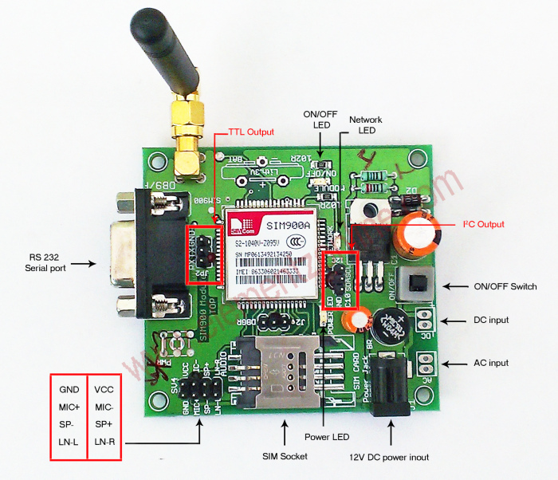

GSM/GPRS Modem-RS232 is built with Dual Band GSM/GPRS engine- SIM900A, works on frequencies 900/ 1800 MHz the Modem is coming with RS232 interface, which allows you connect PC as well as microcontroller with RS232 Chip (MAX232). The baud rate is configurable from 9600-115200 through AT command. The GSM/GPRS Modem is having internal TCP/IP stack to enable you to connect with internet via GPRS. It is suitable for SMS, Voice as well as DATA transfer application in M2M interface. The onboard Regulated Power supply allows you to connect wide range unregulated power supply. Using this modem, you can make audio calls, SMS, Read SMS; attend the incoming calls and internet through simple AT commands.

**10. GPS MODULE-:**

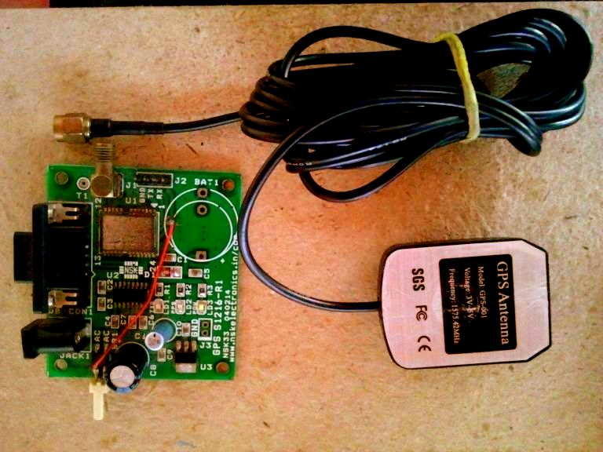

Firstly, the signal of time is sent from a GPS satellite at a given point. Subsequently, the time difference between GPS time and the point of time clock which GPS receiver receives the time signal will be calculated to generate the distance from the receiver to the satellite. The same process will be done with three other available satellites. It is possible to calculate the position of the GPS receiver from distance from the GPS receiver to three satellites. However, the position generated by means of this method is not accurate, for there is an error in calculated distance between satellites and a GPS receiver, which arises from a time error on the clock incorporated into a GPS receiver.

1. **FABRICATION OF PCB**

* P.C.B. is printed circuit board which is of insulating base with layer of thin foil.
* The circuit diagram is then drawn on the P. C. B. with permanent marker and then it is dipped in the solution of ferric chloride so that unwanted copper is removed from the P.C.B., thus leaving components interconnection on the board.
* The specification of the base material is not important to know in most of the application, but it is important to know something about copper foil which is drawn through a thin slip.
* The resistance of copper foil will have an effect on the circuit operation.
* Base material is made of lamination layer of suitable insulating material such as treated paper, fabric; or glass fibres and binding them with resin. Most commonly used base materials are formed paper bonded with epoxy resin.
* It is possible to obtain a range of thickness between 0.5 mm to 3 mm.
* Thickness is the important factor in determining mechanical strength particularly when the commonly used base material is “Formed” from paper assembly.
* Physical properties should be self supporting these are surface resistivity, heat dissipation, dielectric, constant, dielectric strength.
* Another important factor is the ability to withstand high temperature.

**6. PCB LAYOUT**

* **PCB LAYOUT 1-:**

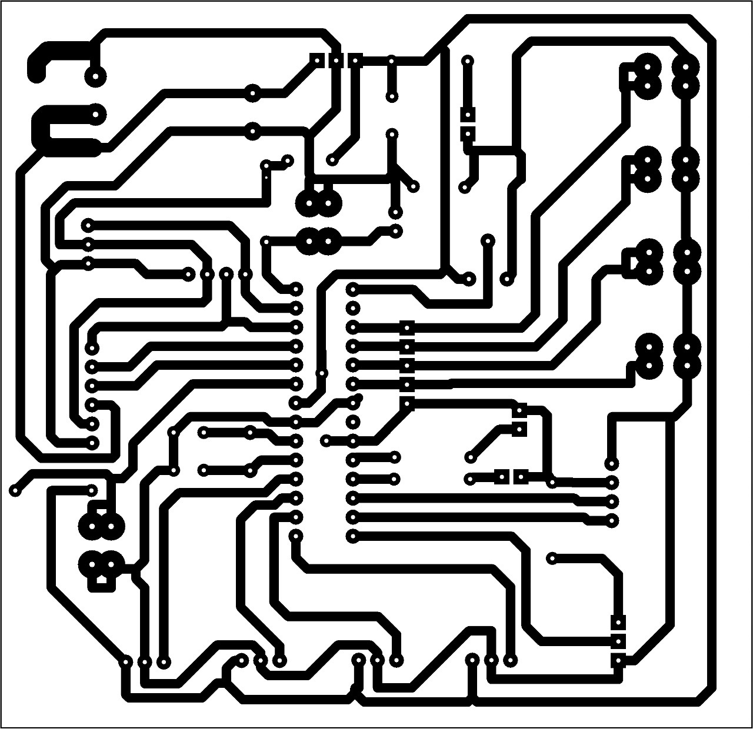

* **PCB LAYOUT 2-:**

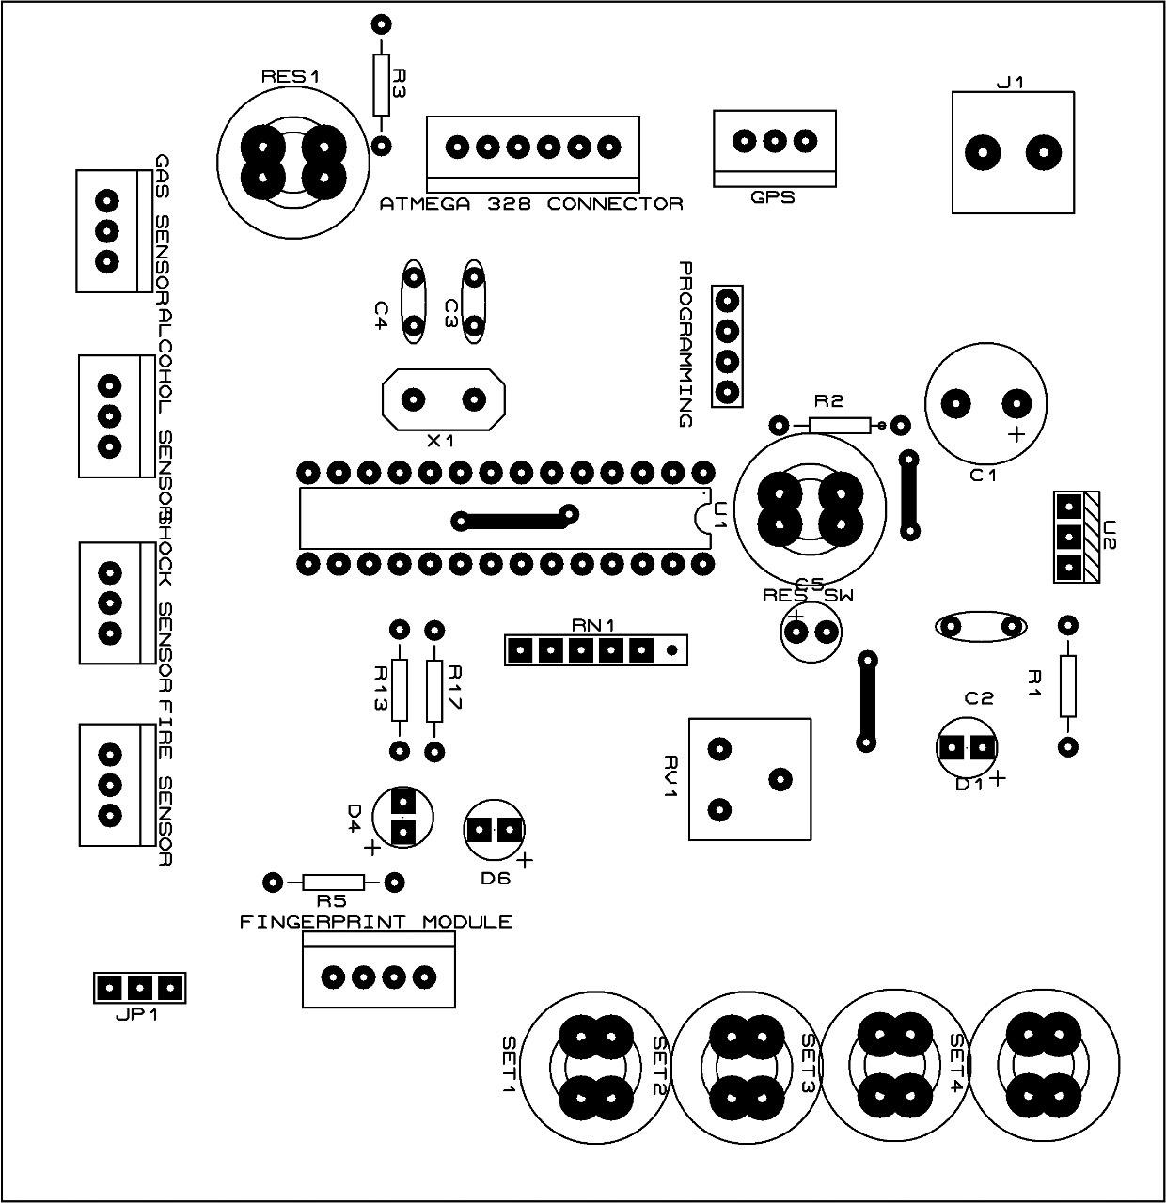

* **PCB LAYOUT 3-:**

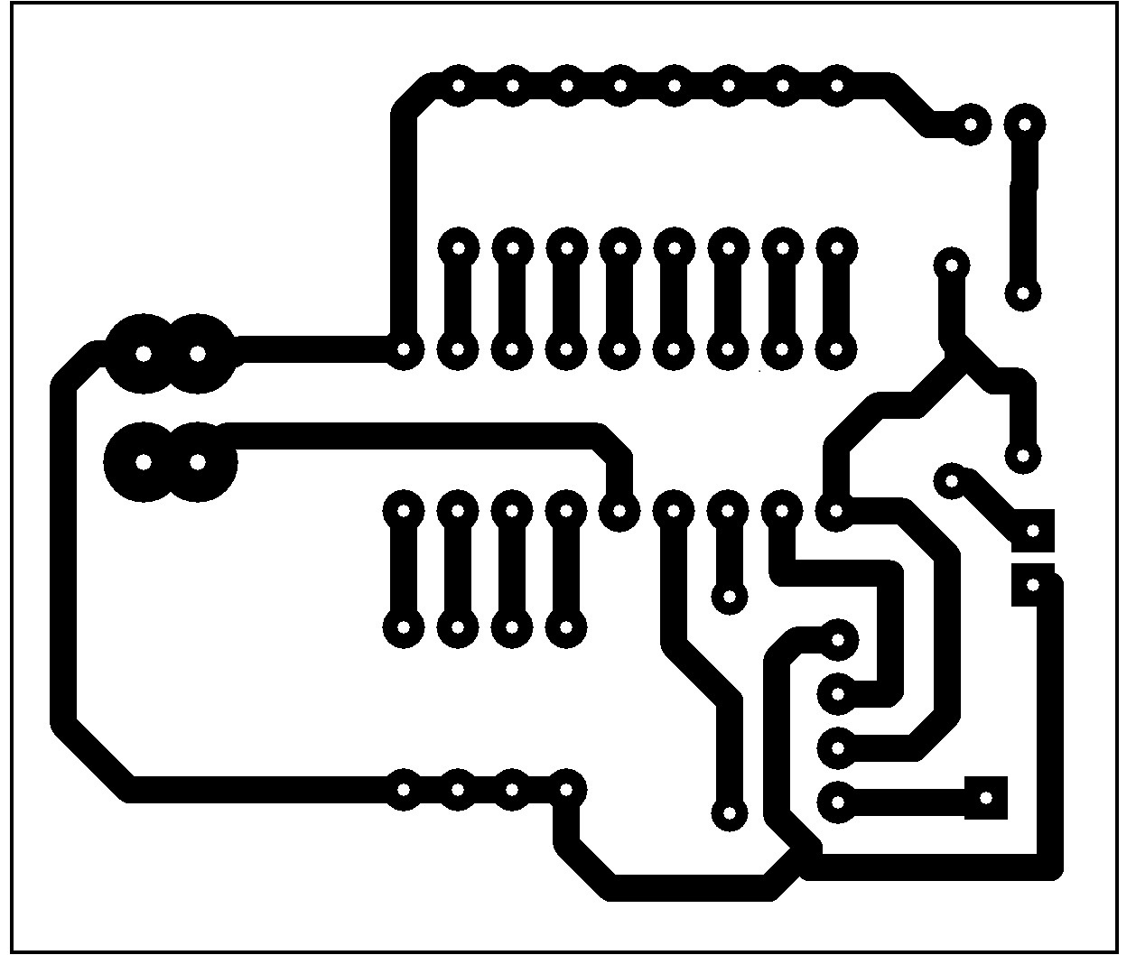

* **PCB LAYOUT 4-:**

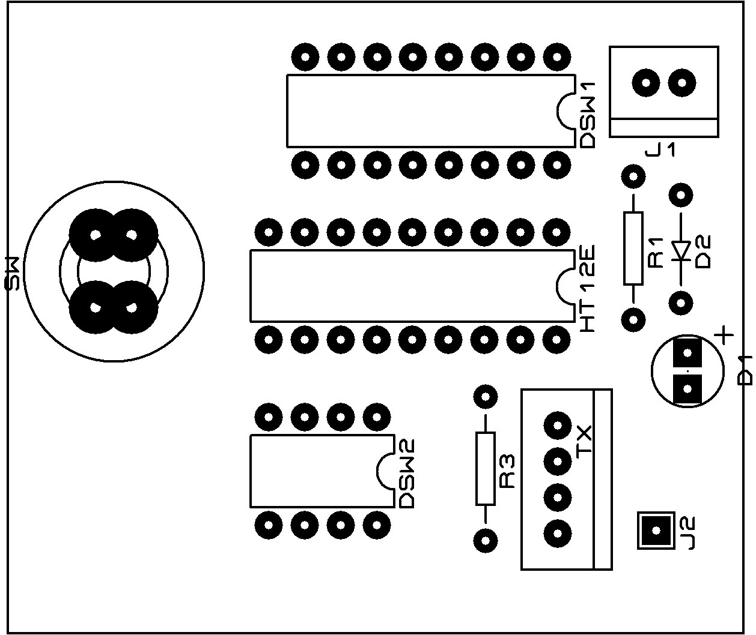

**7. SOFTWARE DEVELOPMENT**

**SOFTWARE DEVELOPMENT**

An assembly (or assembler) language, often abbreviated as, is a low-level programming language for a computer, or other programmable device, in which there is a very strong (generally one-to-one) correspondence between the language and the architecture’s machine code instructions. Each assembly language is specific to particular computer architecture, in contrast to most high-level programming languages, which are generally portable across multiple architectures, but require interpreting or compiling.

Assembly language may also be called symbolic machine code.

Assembly language is converted into executable machine code by utility program referred to as an assembler. The conversion process is referred to as assembly, or assembling the source code. Assemblytime is the computational step where an assembler is run. Assembly language uses a mnemonic to represent each low-level machine instruction or operation, typically also each architectural register, flag, etc.

Many operations require one or more operands in order to form a complete instruction and most assemblers can take expressions of numbers and named constants as well as registers and labels as operands, freeing the programmer from tedious repetitive calculations. Depending on the architecture, these elements may also be combined for specific instructions or addressing modes using offsets or other data as well as fixed addresses. Many assemblers offer additional mechanisms to facilitate program development, to control the assembly process, and to aid debugging.

* **PROGRAMME-:**

**#include <Adafruit_Fingerprint.h>**

**#include <Wire.h>**

**#include <LiquidCrystal_I2C.h>**

**// Set the LCD address to 0x27 for a 16 chars and 2 line display**

**LiquidCrystal_I2C lcd(0x3F, 16, 2);**

**#include<SoftwareSerial.h>**

**#include "TinyGPS++.h"**

**TinyGPSPlus gps;**

**SoftwareSerial mySerial(11,10);**

**const int RED_LED = 12;**

**const int GREEN_LED = 13;**

**const int ON_OFF_Switch = 4;**

**const int Emergency_SW = 9;**

**const int Gas_Sensor = 5;**

**const int Alcohol_sensor = 6;**

**const int Fire_sensor = 7;**

**const int Shock_sensor = 8;**

**const int SW_1 = A3;**

**const int SW_2 = A2;**

**const int SW_3 = A1;**

**const int Speed_sensor = A0;**

**int Speed_sensor_value=0;**

**boolean Gas = false;**

**boolean Alcohol = false;**

**boolean Accident = false;**

**boolean Fire = false;**

**boolean Emergency = false;**

**boolean Shock = false;**

**boolean engine_start=false;**

**String SM_ARU_LAT;**

**Adafruit_Fingerprint finger = Adafruit_Fingerprint(&mySerial);**

**int getFingerprintEnroll(int id);**

**int getFingerprintID();**

**void f_enroll();**

**void f_erase();**

**int enroll=0,normal=0;**

**int FINGERPRINT_NOT_FOUND=0,CONTROL=0;**

**int e = 0;**

**int i=0;**

**int buttonState_1=1,buttonState_2=1,buttonState_3=1,buttonState_4=1;**

**void setup()**

**{**

**Serial.begin(9600);**

**mySerial.begin(9600);**

**Serial.println("SM_ARU...");**

**pinMode(RED_LED, OUTPUT);**

**pinMode(GREEN_LED, OUTPUT);**

**pinMode(Gas_Sensor, INPUT);**

**pinMode(Alcohol_sensor, INPUT);**

**pinMode(Fire_sensor, INPUT);**

**pinMode(Shock_sensor, INPUT);**

**pinMode(Emergency_SW, INPUT);**

**pinMode(ON_OFF_Switch, INPUT);**

**digitalWrite(GREEN_LED,LOW);**

**digitalWrite(RED_LED,HIGH);**

**pinMode(SW_1, INPUT);**

**pinMode(SW_2, INPUT);**

**pinMode(SW_3, INPUT);**

**lcd.begin();**

**lcd.clear();**

**lcd.setCursor(0,0);**

**lcd.print("SM_ARU...");**

**lcd.setCursor(0,1);**

**lcd.print(" Vehical System");**

**delay(2000);**

**buttonState_2 = digitalRead(SW_2);**

**if(buttonState_2==LOW)**

**{**

**lcd.clear();**

**delay(2000);**

**while(normal==0)**

**{**

**lcd.setCursor(0,0);**

**lcd.print("Press S1> Enroll");**

**lcd.setCursor(0,1);**

**lcd.print("Press S2> Normal");**

**buttonState_1 = digitalRead(SW_1);**

**if(buttonState_1==LOW)**

**{system_enroll_process();}**

**buttonState_2 = digitalRead(SW_2);**

**if(buttonState_2==LOW)**

**{normal=1;lcd.clear();delay(2000);}**

**buttonState_3 = digitalRead(SW_3);**

**if(buttonState_3==LOW)**

**{f_erase();}**

**}**

**}**

**lcd.clear();**

**}**

**void loop()**

**{**

**Engine_start_process();**

**while(engine_start==true)**

**{**

**sensor_status_read();**

**}**

**}**

**void sensor_status_read()**

**{**

**lcd.clear();**

**GPS_data();**

**lcd.clear();**

**shock_read();**

**Fire_read();**

**gas_read();**

**alcohol_read();**

**Speed_read();**

**Emergency_read();**

**sensor_data_update();**

**}**

**void Speed_read()**

**{**

**int speed_1=0;**

**if (engine_start == true)**

**{**

**Speed_sensor_value=analogRead(Speed_sensor);**

**Speed_sensor_value = map(Speed_sensor_value, 0, 1023, 0,9);**

**speed_1=Speed_sensor_value*20;**

**lcd.setCursor(0,1);**

**lcd.print("Speed: ");**

**lcd.print(speed_1);**

**lcd.print("Km/h" );**

**}**

**else**

**{**

**lcd.setCursor(0,1);**

**Speed_sensor_value=0;**

**lcd.print("Speed: ");**

**lcd.print(Speed_sensor_value);**

**lcd.print("Km/h" );**

**}**

**delay(1000);**

**}**

**{**

**p = finger.getImage();**

**switch (p)**

**{**

**case FINGERPRINT_OK:**

**// Serial.println("Image taken");**

**lcd.clear();**

**lcd.setCursor(0, 0);**

**lcd.print(" Image taken ");**

**delay(500);**

**break;**

**case FINGERPRINT_NOFINGER:**

**//Serial.println(".");**

**delay(500);**

**break;**

**case FINGERPRINT_PACKETRECIEVEERR:**

**//Serial.println("Communication error");**

**lcd.clear();**

**lcd.setCursor(0, 0);**

**lcd.print(" Communication ");**

**lcd.setCursor(0, 1);**

**lcd.print(" Error ");**

**delay(500);**

**break;**

**case FINGERPRINT_IMAGEFAIL:**

**8. ADVANTAGES**

**AND**

**APPLICATIONS**

* **ADVANTAGES:-**

1. This method of analyzing or detecting the presence of alcohol in breath is relatively quick analysis as compared to other techniques.
2. The sensor used in this project are smaller in size, not so bulky, hence can be carried.
3. Unfortunately if your accident is done in future, then message of accident will automatically send to our relatives with the help of GRS Module.
4. With the help of GPS we get exact position of the accident place within 15 seconds.

* **APPLICATION:-**

The following are application of our project:-

1. This project is used to control accidents on road.
2. It is used in Traffic based project.
3. These are applications of our project.

**9. FUTURE SCOPE**

**AND**

**BENEFITS**

* **FUTURE SCOPE OF OUR PROJECT IS GIVEN BELOW:-**

1. Presently only SMS feature is available, we can include the call feature in future.
2. Using android application we also stop the engine.
3. Microphone could be interfaced to theGSM/GPS module so during theft activity voice call could be establishedwith the owner.

**10. CONCLUSION**

* **CONCLUSION:-**

In this project we proposed the system for securing the vehicles. Now days, there are some problem faced by our society such as increase in the number of car accident, increase in the number of car thefts, drink and drive, etc. So, our project is perfect solution on that. In this project low cost vehicle tracking system has been developed. Designed embedded circuit tracks the vehicles and records the position of vehicle. This system also indicates about the accident place to ambulance/police services.

As a future development presently only SMS feature is available, we can include the call feature in future. Using android application we also stop the engine. Microphone could be interfaced to theGSM/GPS module so during theft activity voice call could be establishedwith the owner.

**11. SNAPSHOT**

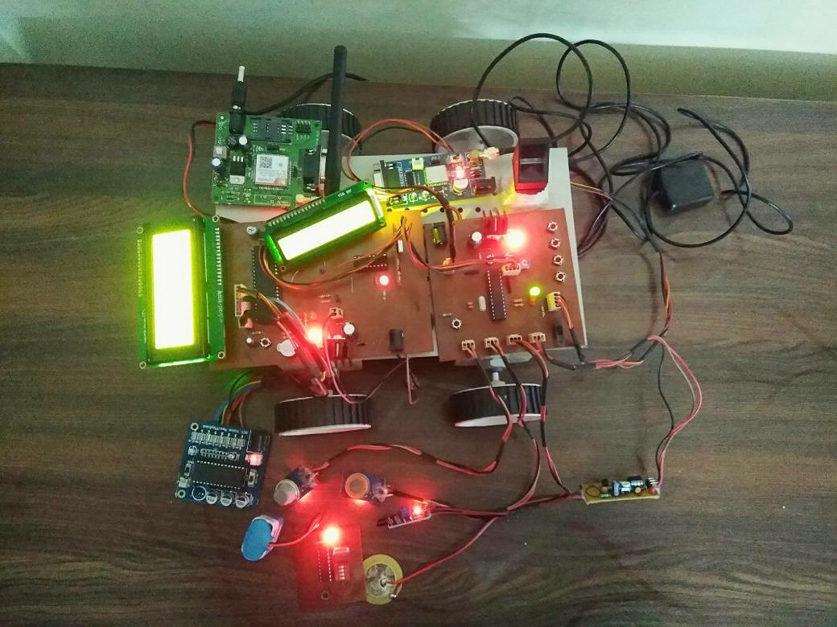

**VEHICLE WITH ADVANCED SAFETY SYSTEM**

**11.BIBLIOGRAPHY**

**REFRENCES**

1. [www.Microchip.com](http://www.Microchip.com)
2. [www.national.com](http://www.national.com)
3. www.engineergarage.com
4. [www.electronicsforu.com](http://www.electronicsforu.com)
5. www.howstuffworks.com
6. “Microcontroller PIC 16F74” [www.microcontroller.com](http://www.microcontroller.com)

**12. DATASHEET**

